**Skill-End Project**

**Weather API Testing**

**Objective:** Identify the steps to perform Postman API testing

**Tools required:** Postman and an email ID

**Pre-requisites:** Knowledge of Postman and API testing

Search for **Open Weather API**

<https://openweathermap.org/api>

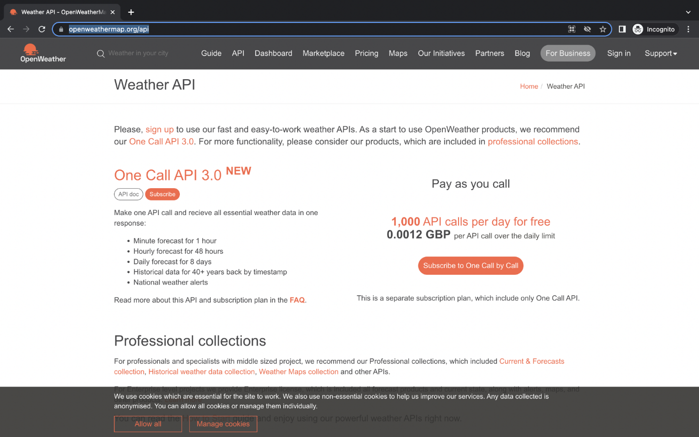

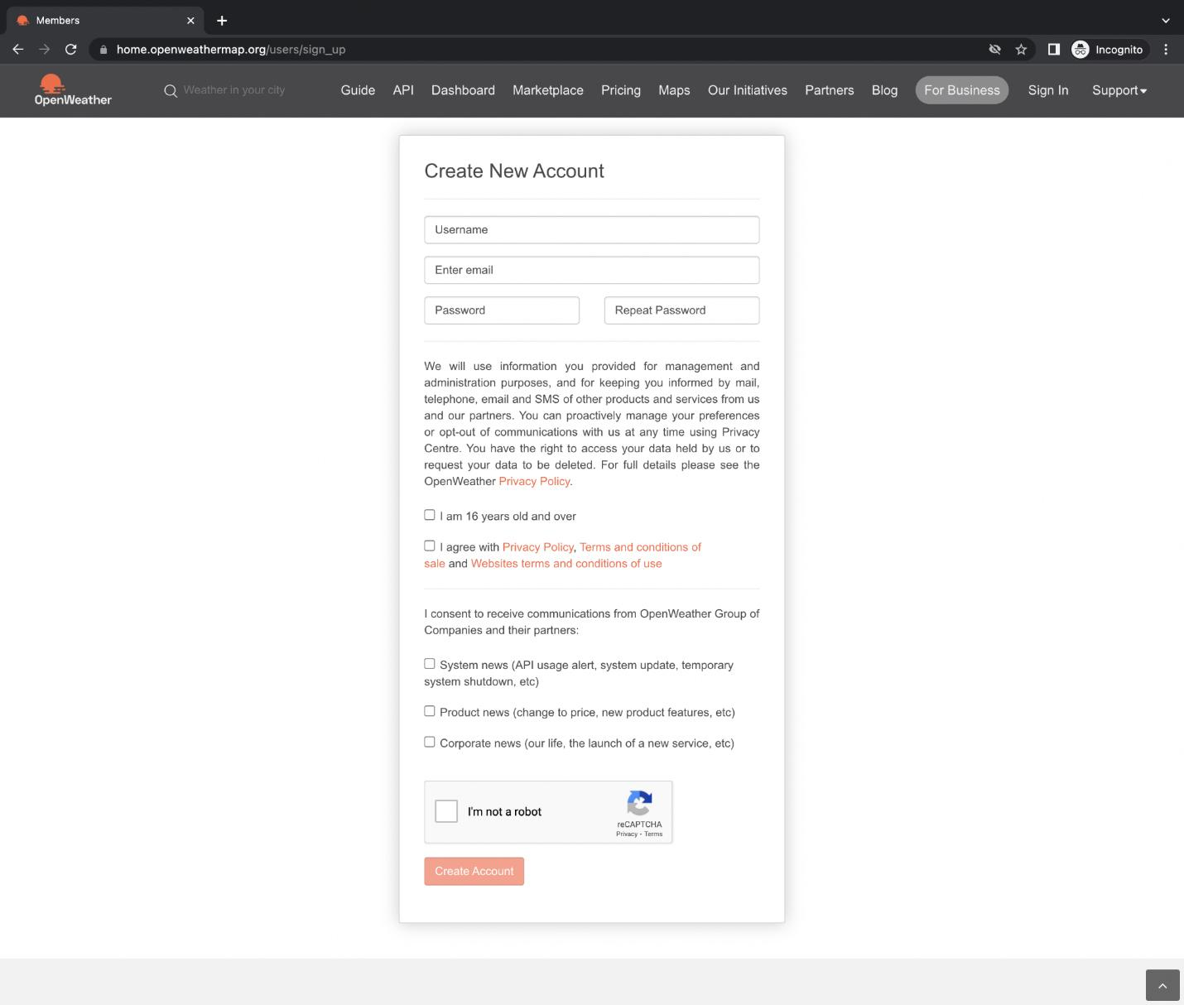

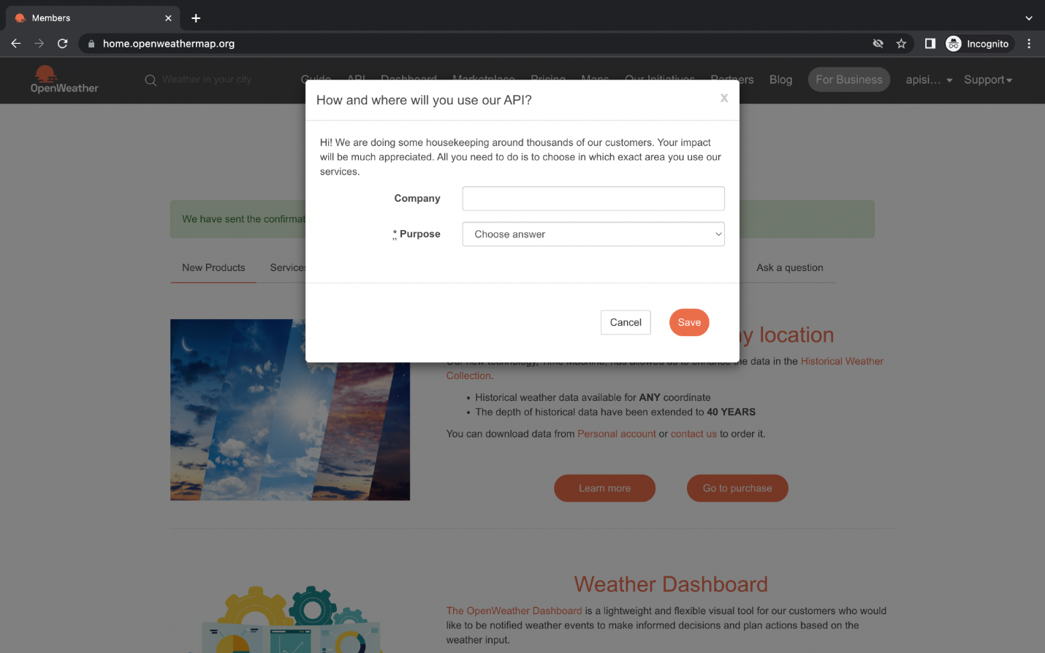

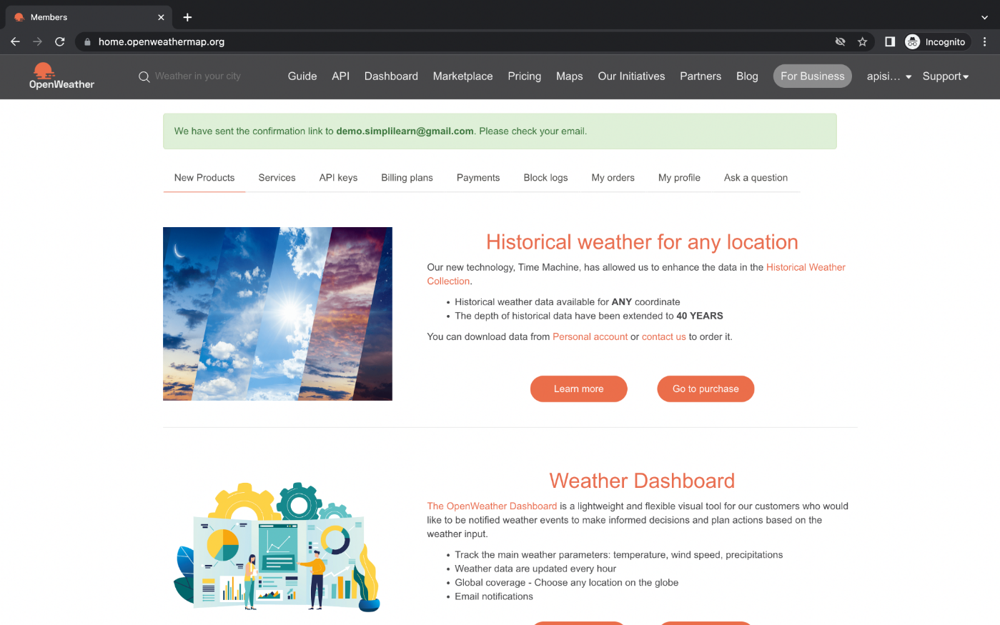

**My API Keys**

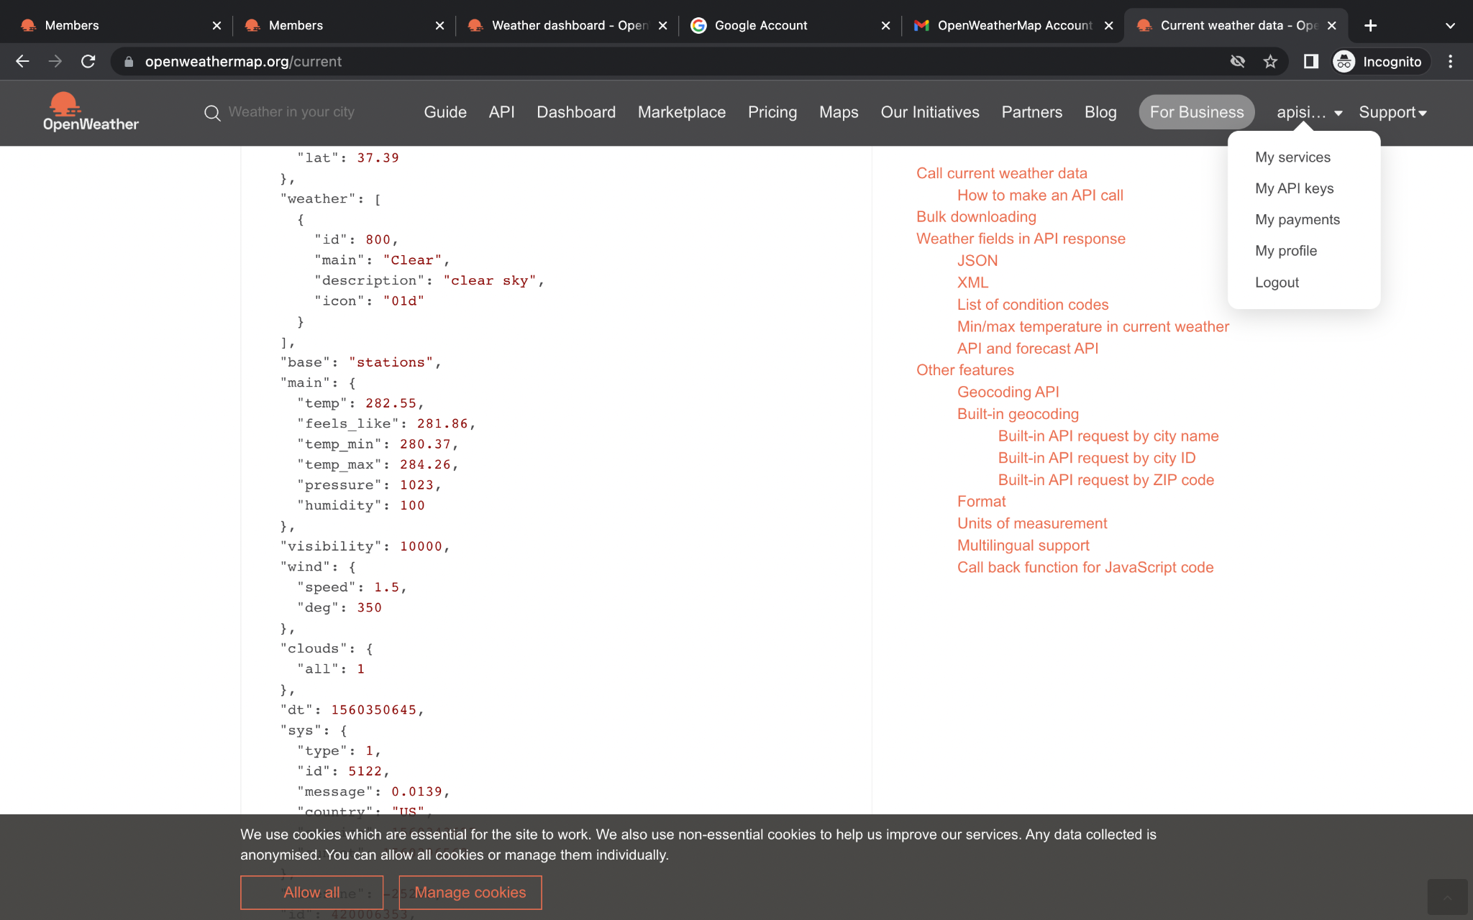

Users can see an **API** key

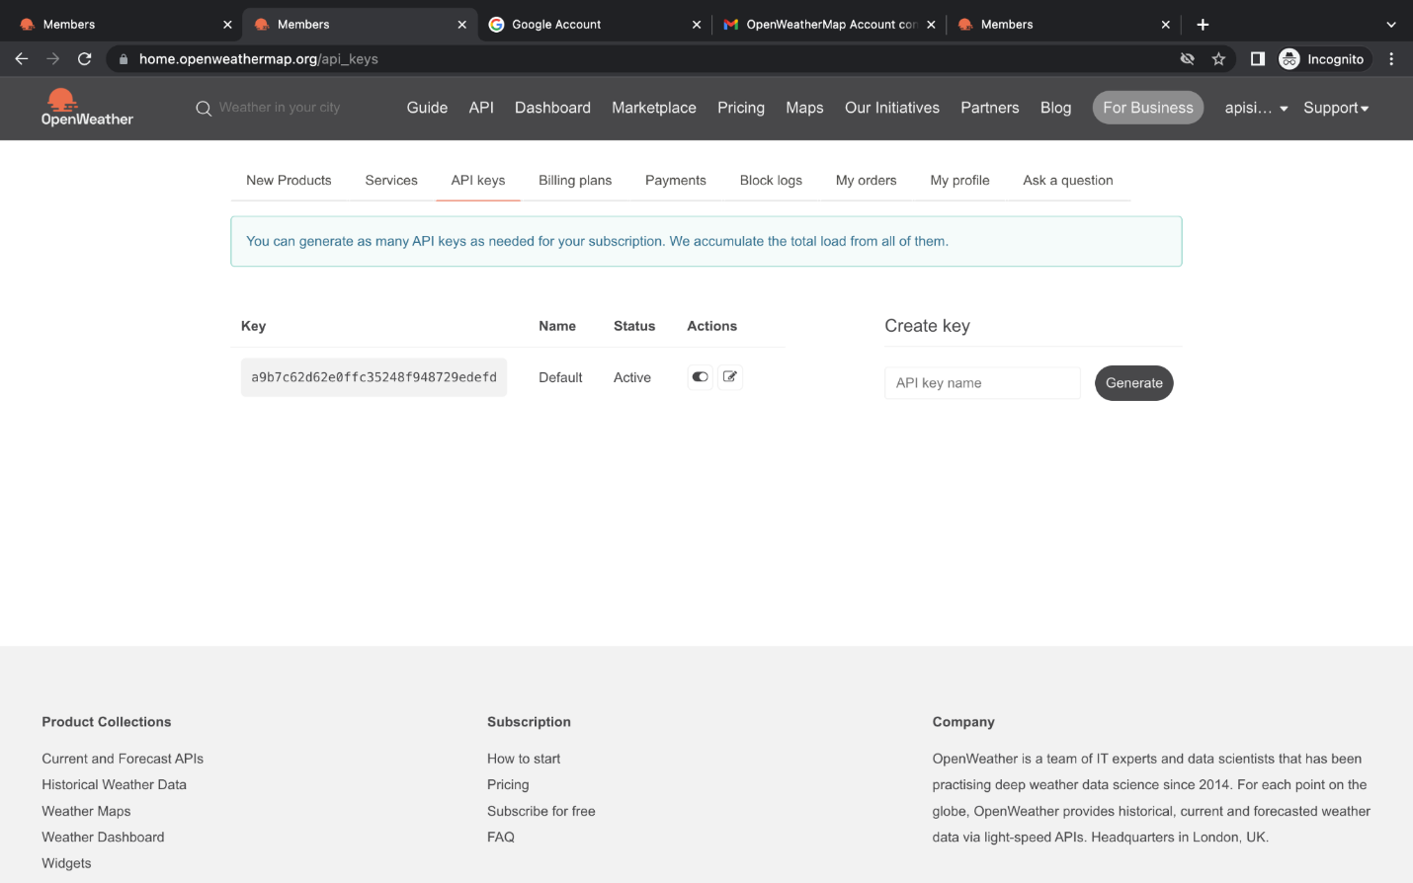

**Current** and **Forecast API**

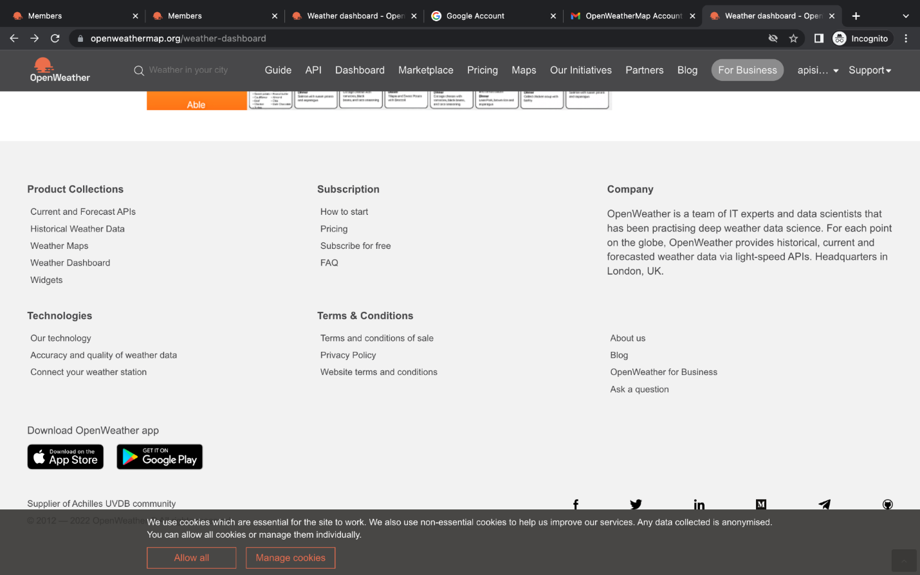

:Users can find **API** details – information related to the **Request**, **Response**, **Parameters,** and **Response fields**.

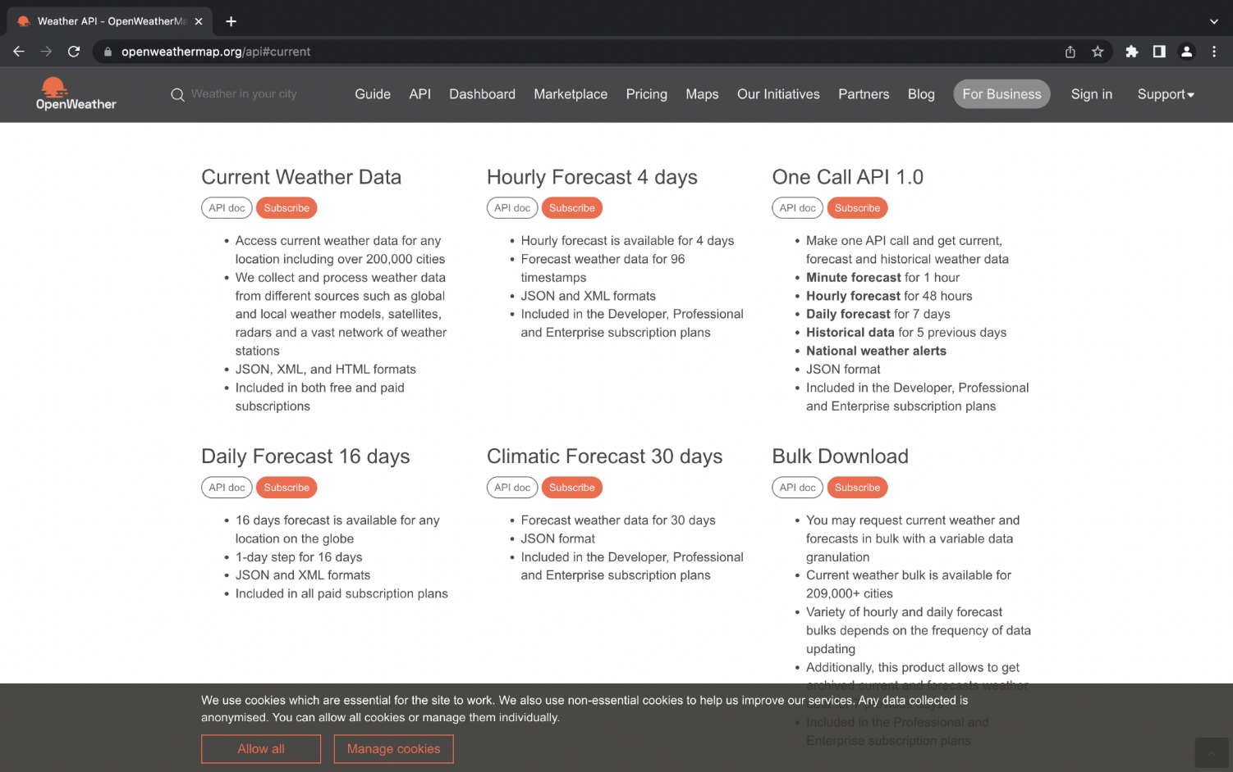

Check out all to complete the task

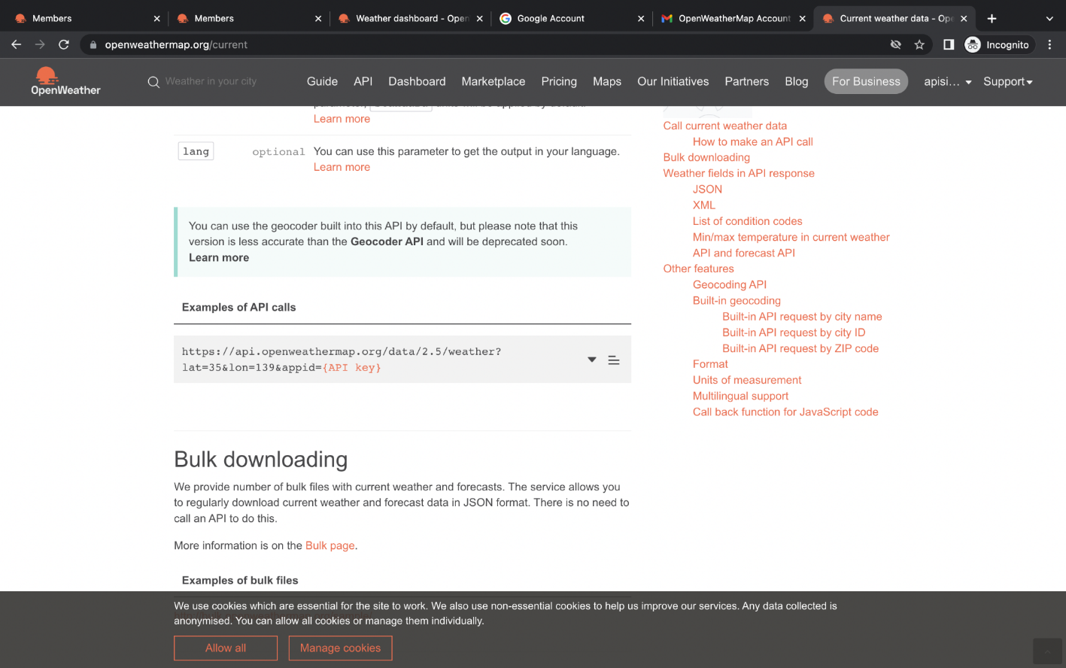

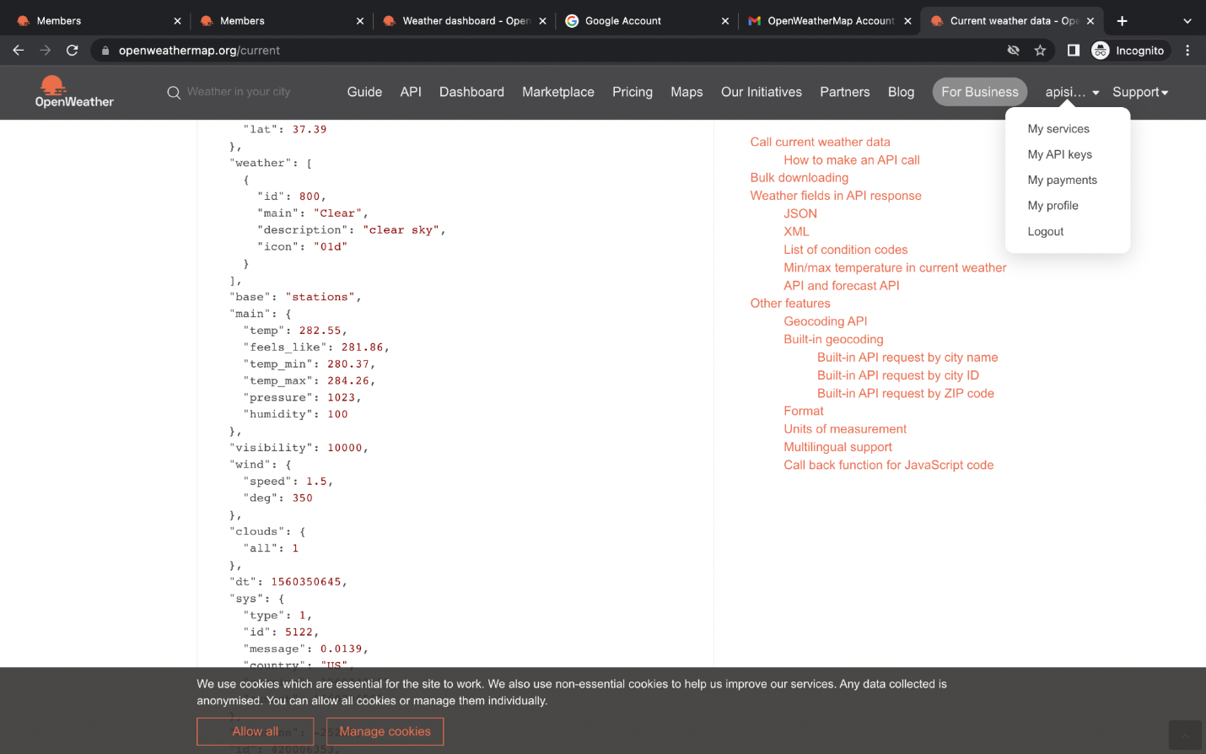

**Example URL:**

https://api.openweathermap.org/data/2.5/weather?lat=35&lon=139&appid= {API key}

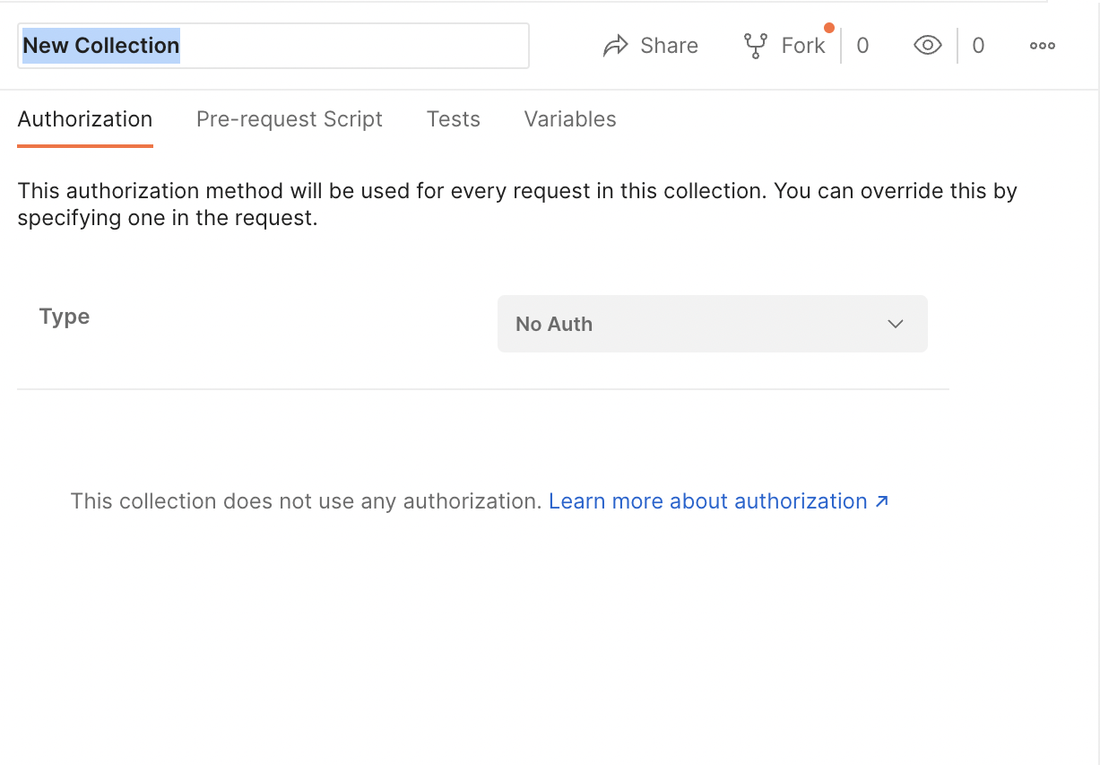

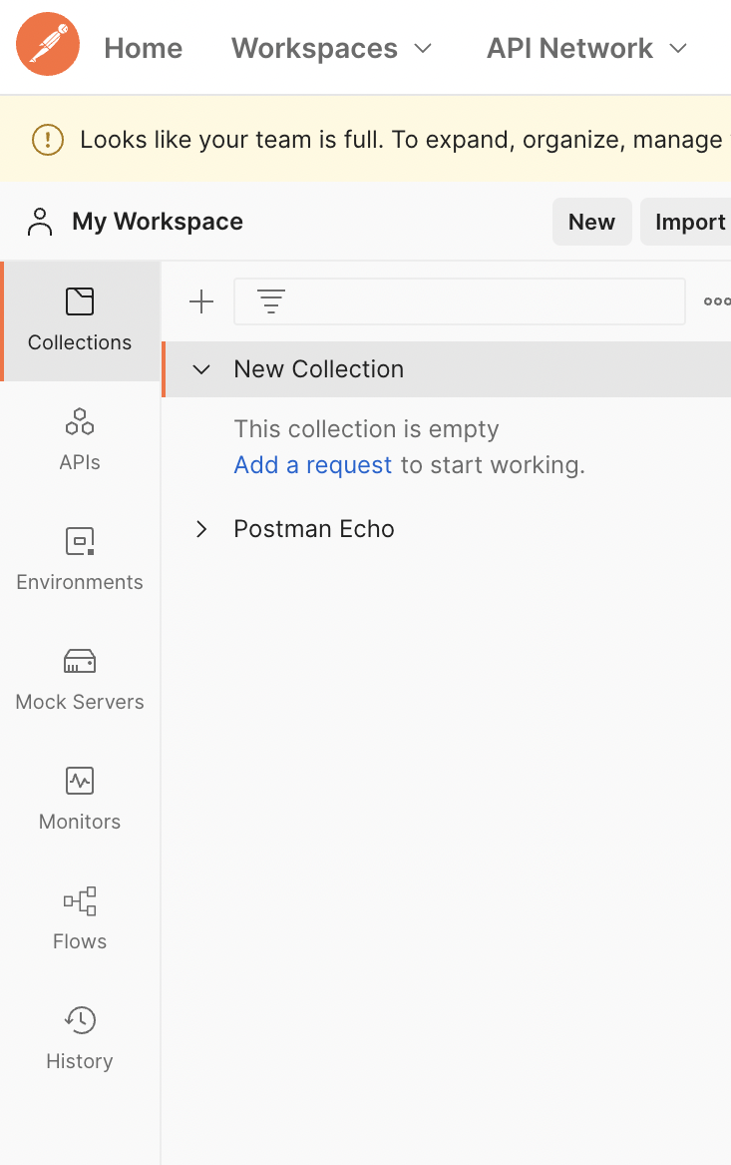

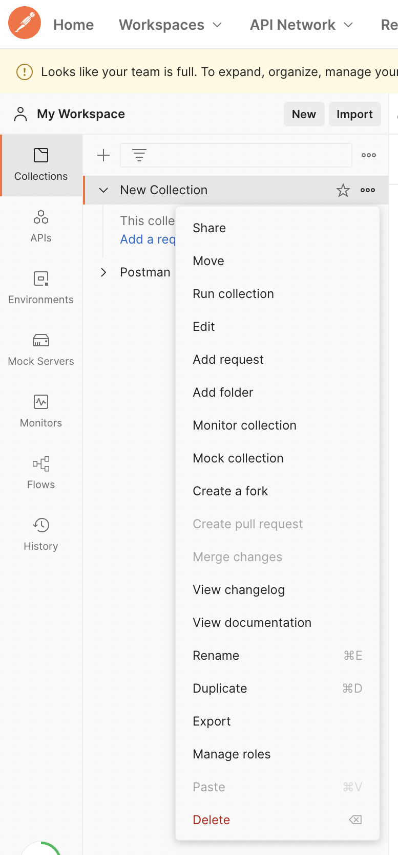

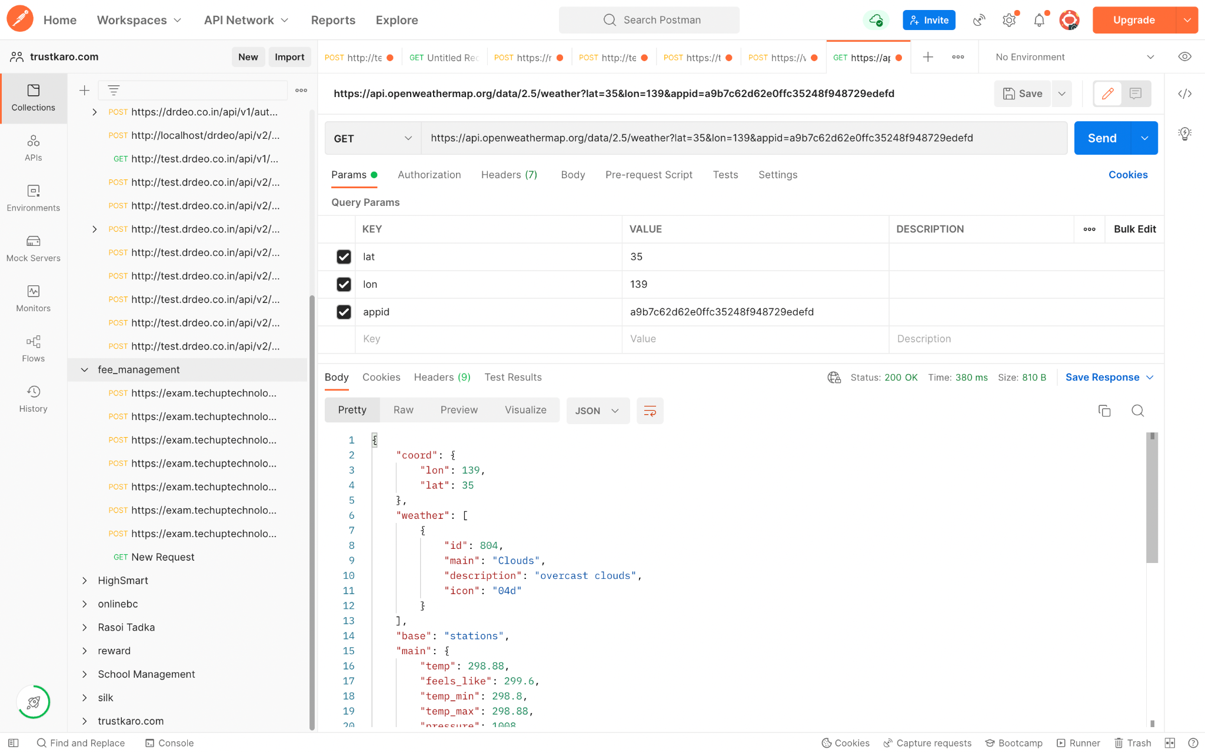

One API is now successfully tested. Users have also created a Collection of API.